**Project Report**

**On**

Garage Management System

Submitted by:

Name: Yerva Yasmithareddy

Roll No: 22701A30A3

Email: yervayasmithareddy@gmail.com

Department of Artificial Intelligence and Data Science

Annamacharya Institute of Technology and Sciences

[Rajampeta]

Under the Guidance of:

[Annnapoorna]

Academic Year: 2025–2026

## Abstract

The **Garage Management System** is a cloud-based application developed using the Salesforce platform to automate and streamline the operations of vehicle service centers. This system is designed to handle various garage tasks such as customer management, vehicle tracking, service booking, mechanic assignment, inventory control, and billing—all in one centralized platform.

Traditional garage workflows involve manual entries, paperwork, and delays in accessing information, leading to inefficiencies and poor customer service. By leveraging Salesforce’s tools like Custom Objects, Lightning Pages, Flows, and Reports, this project offers a user-friendly solution that improves speed, accuracy, and overall productivity.

The system ensures real-time data access, reduces errors, and provides service history, reminders, and performance analytics through dashboards. It benefits garage owners, employees, and customers by making garage operations more organized, transparent, and efficient.

**Table of Contents**

1. Abstract
2. Problem Statement
3. Overview of Garage Management System
4. Objectives
5. Requirement Analysis & Planning
   * 1. Understanding Business Requirements
     2. Project Scope and Objectives
     3. Data Model & Security Model
6. Introduction
   * 1. Purpose of the Project
     2. Key Modules Implemented
     3. Why Use Salesforce?
     4. Target Users
     5. Technology Stack
7. Architecture of Garage Management System
   * 1. User Interface Layer
     2. Business Logic Layer
     3. Data Layer
     4. Security Layer
     5. Integration & Communication Laye
     6. Key Architecture Features
8. Custom Objects Used in the Project
   * 1. Customer Details
     2. Appointment
     3. Service Records
     4. Billing Details and Feedback
9. Custom Tabs Created
   * 1. Appointments Tab
     2. Billing Details and Feedback Tab
     3. Customer_Details Tab
     4. Service_Records Tab
10. Lightning Experience App Manager
11. Customer Details Object – Detailed Configuration
12. Salesforce Lightning App Manager & Customer Details Object – Summary
13. Billing Details and Feedback Object – Field and Relationship Summary
14. Appointment Object – Key Fields and Features
15. Service Records Object – Fields and User Interface
16. Validation Rules for Form Fields
17. Duplicate Management and Data Integrity
18. User Roles and Permission Settings
19. Sharing Settings and Public Groups
20. Flows and Automation
21. Output Verification
22. Sample Reports
23. Dashboard Overview
24. Social and Business Impact
25. Conclusion
26. Future Scope
27. Reference

## Problem Statement

Traditional automobile service centers often rely on manual processes and paper-based records to manage customer information, service bookings, vehicle histories, billing, and feedback. These outdated methods lead to inefficiencies such as data duplication, errors, delayed service, and poor communication among staff and customers. Managers struggle to gain real-time insights into operations, which limits their ability to make informed business decisions. Furthermore, the lack of automation makes it difficult to maintain service quality, track performance, and respond promptly to customer needs.

There is a clear need for a digital, automated solution that streamlines garage operations, centralizes all information, enables real-time tracking, and enhances both customer service and business management. The Garage Management System CRM project aims to address these challenges by leveraging the Salesforce platform to provide a comprehensive, efficient, and secure management system for modern automobile garages.

Let me know if you want it even shorter or further customized for your specific requirements!

## Overview of Garage Management System

The Garage Management System CRM is a cloud-based solution developed on the Salesforce platform to streamline and automate the day-to-day operations of an automobile service center. This CRM enables efficient handling of customer details, appointment scheduling, service record tracking, billing, and feedback collection. It addresses key business needs such as improving customer satisfaction through timely service updates, maintaining accurate service and billing data, and enabling data-driven decisions with customizable reports and dashboards. With integrated flows, Apex handlers, and visual dashboards, the system ensures operational efficiency and transparency for both customers and garage staff.

### 🎯 ****Objectives:****

The primary objective of developing the **Garage Management System CRM** is to automate and streamline all garage operations by unifying key services onto a user-friendly Salesforce platform. This system is designed to:

* **Centralize customer management:** Capture, organize, and securely store detailed customer and vehicle records.
* **Enable seamless appointment booking:** Simplify the scheduling and tracking of service appointments for both staff and customers.
* **Provide real-time service tracking:** Monitor the status of repairs and maintenance throughout their lifecycle.
* **Deliver transparent billing with feedback mechanisms:** Generate accurate invoices and collect customer feedback to continually improve service quality.
* **Eliminate manual processes and reduce errors:** Automate repetitive tasks and validation to improve data accuracy and save time.
* **Enhance customer experience:** Provide timely updates and maintain service histories to build trust and satisfaction.

Additionally, the CRM:

* Offers **role-based access** to ensure data privacy and tailored user permissions.
* Delivers **customized reports** and **actionable dashboards** to provide managers and staff with meaningful insights for informed decision-making.
* Supports continuous improvement by leveraging data analytics for operational efficiency and customer retention strategies.

Overall, the Garage Management System CRM aims to elevate service delivery, foster stronger customer relationships, and drive business growth through intelligent automation and centralized management.

## Requirement Analysis & Planning

### Understanding Business Requirements:

The goal is to manage all garage operations from a central, digital system that boosts efficiency and customer satisfaction. The system replaces manual records for customer data, appointments, service details, billing, and feedback with automated, real-time tracking. Managers can monitor staff, quality, and revenue, while customers easily schedule appointments and get service updates.

## Project Scope and Objectives

* Develop a Salesforce CRM to digitize all major garage processes including customer management, service tracking, billing, and feedback.
* Enable appointment booking and service monitoring.
* Automate workflows with Flows, Triggers, and Rules.
* Control data access through roles and sharing.
* Provide dashboards and reports.
* Improve communication with real-time updates.

## Data Model & Security Model

* **Custom Objects:**
* Customer_Details__c (Customer info)
* Appointment__c (Service bookings)
* Service_Records__c (Work details)
* Billing_Details_and_Feedback__c (Invoices, feedback)

**Key Relationships:**

* Customer → Appointments (1:M)
* Appointment → Service Records (1:M)
* Service Record → Billing/Feedback (1:1)

**Security:**

* Private access to sensitive records.
* Sharing rules for management oversight.
* Roles: CEO > Manager > Sales > Service Staff.
* Field security for billing details.
* Profiles & permissions tailored to roles.

# Introduction

The **Garage Management System** is a cloud-based application developed using the **Salesforce platform** to efficiently manage and automate daily garage operations. It is designed to handle key functions such as customer management, vehicle service tracking, appointment scheduling, spare parts inventory, billing, and technician assignments. Traditionally, many garages depend on manual record-keeping, which often leads to delays, errors, and poor service quality. This project leverages Salesforce’s powerful tools—like Custom Objects, Flows, Reports, and Dashboards—to automate these processes and ensure real-time access to accurate information.

The system helps service centers improve operational efficiency, reduce paperwork, and deliver better customer experiences. With cloud access, the system allows staff to manage tasks from anywhere, anytime. It also empowers garage managers with data-driven insights through visual dashboards, aiding in smarter business decisions. Overall, the Garage Management System enhances productivity, increases transparency, and supports the digital transformation of traditional garages.

# Architecture of Garage Management System (Salesforce CRM)

## High-Level Overview

The Garage Management System on Salesforce is built using a multi-layered architecture which organizes all garage operations—such as customer management, appointments, service tracking, and billing—into a secure, efficient, and easily expandable system.

## 1. User Interface Layer

* **Salesforce Lightning Experience:**  
  Modern UI provides users (admin, manager, mechanic, receptionist) access to tabs for Customers, Appointments, Services, and Billing.
* **Mobile Access:**  
  Salesforce Mobile App gives staff flexibility to manage tasks on the go.

## 2. Business Logic Layer

* **Automations:**
* **Flows:** Automate routine tasks (e.g., appointment reminders, status updates).
* **Process Builders:** Define business processes (e.g., approvals, notification triggers).
* **Apex Triggers/Classes:** Custom logic for complex operations (e.g., updating inventory after service, batch notifications).

## 3. Data Layer

* **Custom Objects:**
* **Customer_Details__c:** Stores customer and vehicle info.
* **Appointment__c:** Booking records for services.
* **Service_Records__c:** Logs all work performed.
* **Billing_Details_and_Feedback__c:** Handles payments and feedback.
* **Relationships:**
* One-to-many links (e.g., one customer → many appointments).
* Service and billing records link directly to appointments for full activity tracking.
* **Reports & Dashboards:**
* Aggregate data from all objects for business insights.

## 4. Security Layer

* **Profiles & Permission Sets:**  
  Define what each user type (e.g., admin, mechanic, receptionist) can see and do within the system.
* **Role Hierarchy & Sharing Rules:**  
  Controls visibility—managers see all subordinate records, other roles see only their own.
* **Field-Level Security:**  
  Sensitive data (like billing details or feedback) is only accessible to authorized users.
* **Organization-Wide Defaults:**  
  Private settings for sensitive objects, ensuring confidentiality.

## 5. Integration & Communication Layer

* **Notifications:**  
  Automated SMS/Email alerts for bookings, service completions, or payment updates.
* **External Integrations (Future-ready):**  
  API connections for payment gateways, IoT diagnostics, or AI chatbots.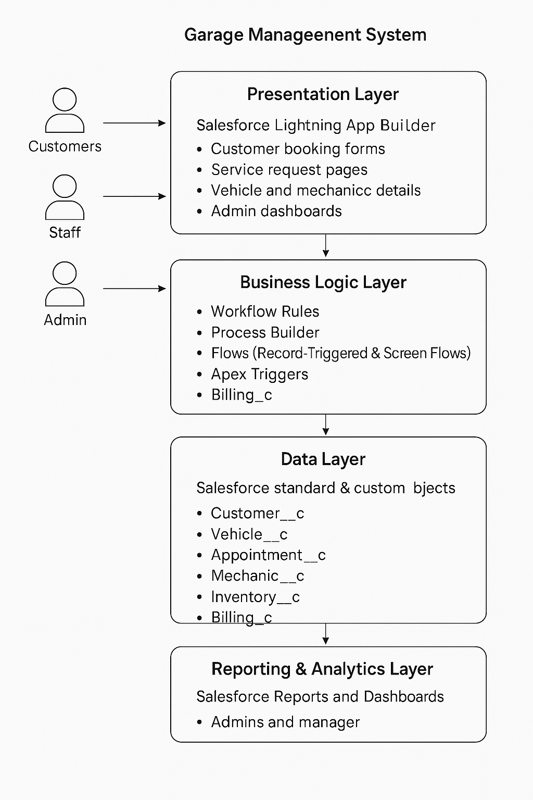

## Key Architecture Features

* **Modular:** Each core activity—customer, appointment, service, billing—is mapped to a dedicated object and interface.
* **Automated:** Most routine actions are handled by flows/processes, reducing mistakes and manual effort.
* **Secure:** Role-based access and field security protect data.
* **Expandable:** New objects, automations, or integrations (like mobile, chatbots, payments) can be added without major redesign.
* This architecture ensures the Garage Management System is easy to use, scalable for future needs, and delivers secure, efficient operations for all garage stakeholders.

## Custom Objects Used in the Project

The following **custom objects** were created in Salesforce to manage garage-related operations:

1. **Customer Details** – Stores customer information such as name, contact, and vehicle.
2. **Appointment** – Records and schedules customer appointments for vehicle servicing.
3. **Service Records** – Maintains information about the services performed on vehicles.
4. **Billing Details and Feedback** – Captures billing information and customer feedback after service.

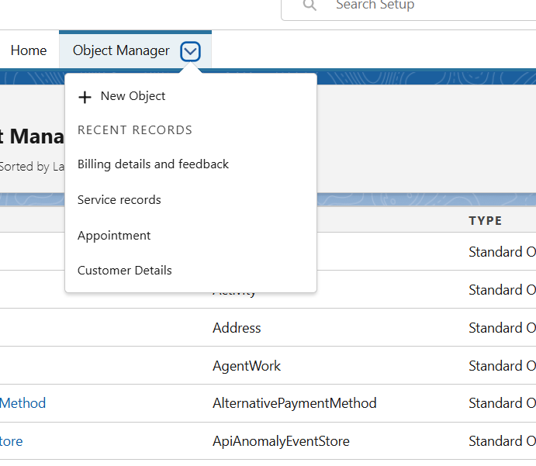

## 1. Customer Details

* **Purpose:**  
  Stores and organizes all relevant customer data, facilitating seamless linkage to their vehicles and service history.
* **Key Fields:**

Customer Name

Contact Number

Email Address

Vehicle Number

Address

* **Features:**

Links each customer to related appointments, service records, and billing records.

Enables reports for customer analysis and segmentation.

Field history tracking is activated to maintain accurate records and ensure

data integrity over time.

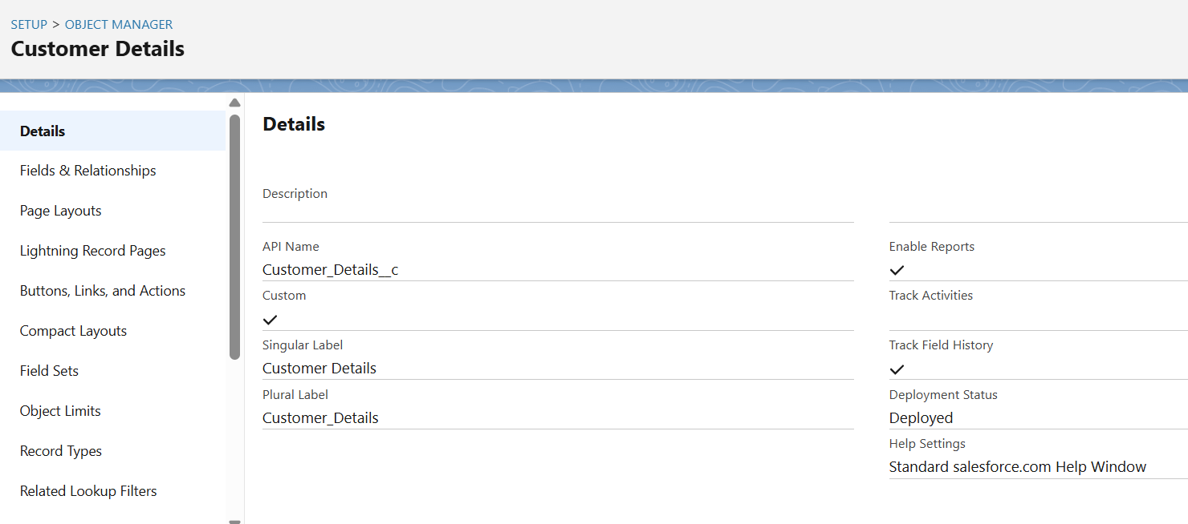

## 2. Appointment

* **Purpose:**  
  Manages the scheduling and tracking of all customer service bookings.
* **Key Fields:**

Appointment Date

Appointment Time

Assigned Mechanic

Service Type (e.g., oil change, repair)

* **Features:**

Facilitates efficient booking management and resource allocation.

Tracks customer visits and prevents scheduling conflicts.

Reports and field history tracking are enabled to monitor booking patterns

and maintain service quality standards.

## Screenshot 2025-07-19 2054073. Service Records

**Service Records** object is used to store details about all garage services provided to vehicles. It includes information like service type, cost, mechanic name, and service status. This object is linked with customer and vehicle details to maintain complete service history. Reports and field tracking are enabled to analyze service performance and history effectively.

* **Purpose:**  
  Documents the details of every garage service performed, ensuring complete and auditable service histories for vehicles.
* **Key Fields:**

Service Type

Service Cost

Mechanic Name

Service Status (e.g., pending, in progress, complete)

* **Features:**

Linked to both customer and vehicle data for unified service histories.

Facilitates evaluation of service trends and mechanic performance.

Reports and field tracking supported for comprehensive performance analysis.

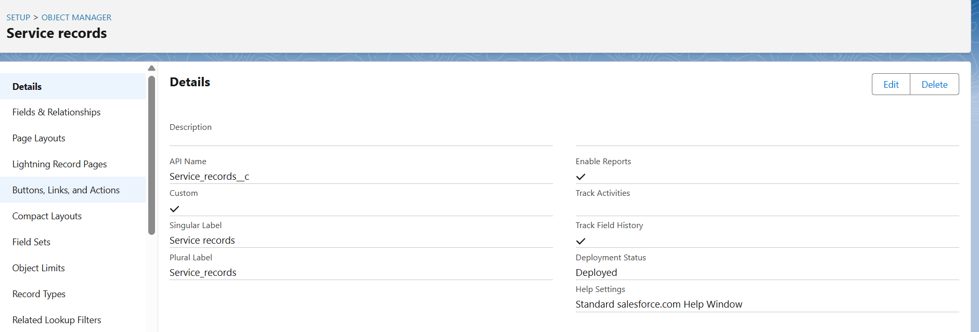

## 4. Billing Details and Feedback

**Billing details and feedback** object is used to manage service charges and collect customer feedback. It includes billing amount, payment status, and feedback comments for each service. This helps the garage maintain financial records and improve service quality based on customer reviews. Reports and field tracking are enabled for transparency and analysis.

* **Purpose:**  
  Centralizes all payment-related information and customer feedback post-service.
* **Key Fields:**

Billing Amount

Payment Status

Feedback Comments

* **Features:**

Helps manage garage financial records accurately.

Enables systematic collection and analysis of customer satisfaction data

for continuous improvement.

Reports and field history tracking implemented for transparency and

reliable record-keeping.

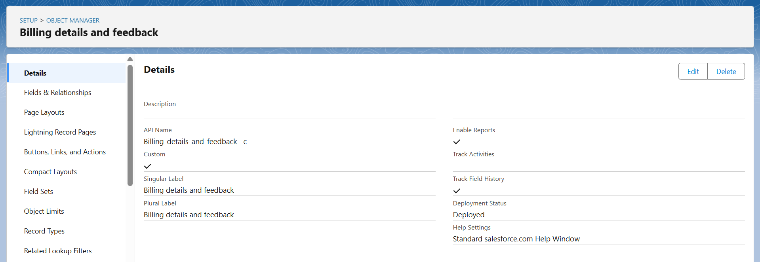

**Custom Tabs Created:**

* **Appointments** – Used to manage and track all service appointments.
* **Billing details and feedback** – Maintains customer bills and their feedback.
* **Customer_Details** – Stores complete customer information and contact details.
* **Service_records** – Keeps records of all vehicle services performed.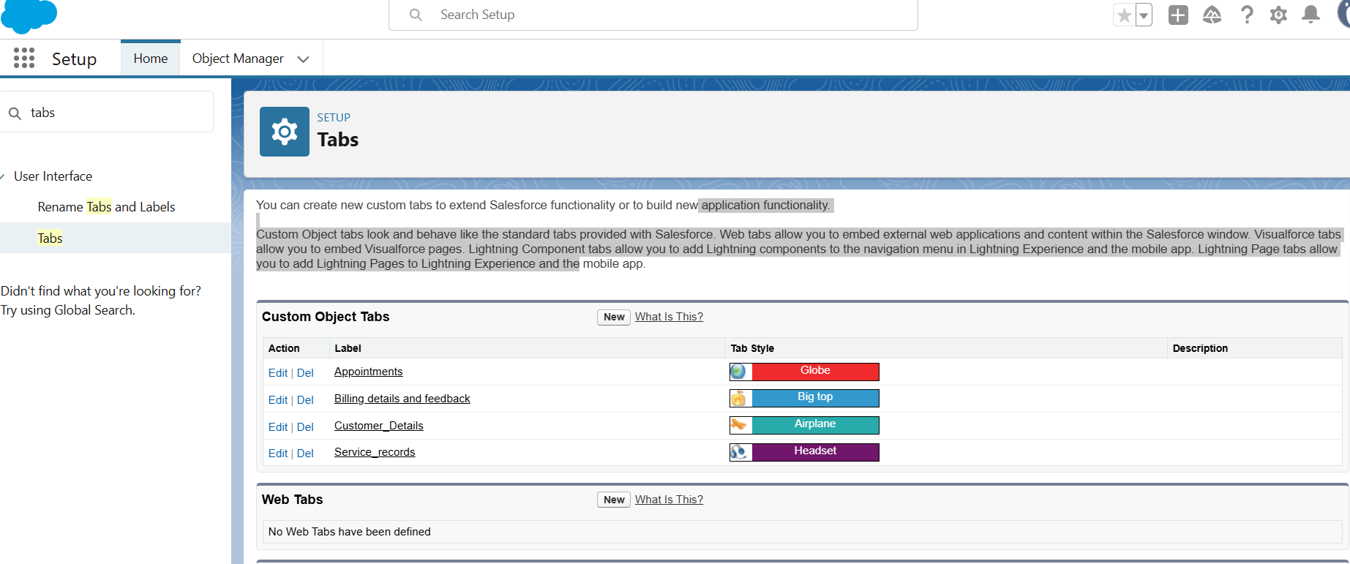

## 1. Appointments Tab

* This tab is created for managing customer service appointments. It allows Users to view, create, and track all vehicle service bookings in one place. Custom fields and flows are used to streamline appointment scheduling and status updates.
* **Purpose:** Central hub for managing all customer service appointments.
* **Functions:**

View, create, and track vehicle service bookings.

Access all scheduled and past appointments in one place.

Streamlined appointment scheduling with custom fields for date, time,

service type, and assigned mechanic.

Integrated with flows to automate reminders, update appointment status,

and trigger subsequent service processes.

* **Benefits:**

Ensures efficient service coordination.

Reduces manual errors and overlapping bookings.

Enables staff to prioritize and allocate resources effectively.

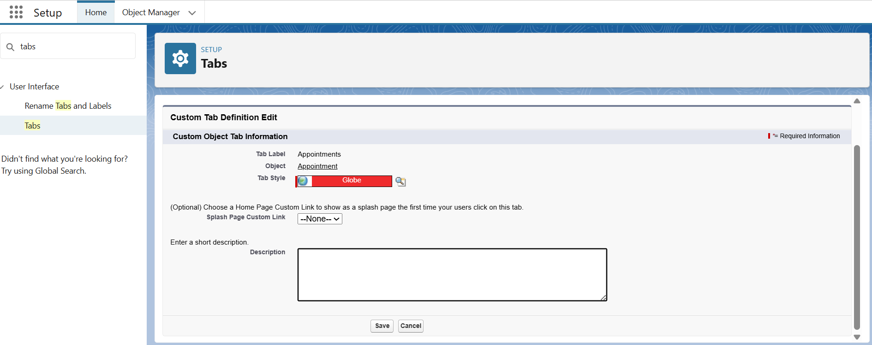

## 2. Billing Details and Feedback Tab

* **Purpose:** Manage billing and collect customer feedback after services.
* **Functions:**

Store and review all billing information related to services rendered.

Track status of payments, outstanding amounts, and generate billing reports.

Capture and maintain customer feedback for each completed service.

Automated calculations and validation rules ensure accuracy and compliance.

* **Benefits:**

Maintains transparency in billing for both staff and customers.

Supports rapid resolution of billing issues.

Collects actionable feedback to monitor and improve service quality.

Provides valuable data for financial analysis and customer satisfaction measurement.

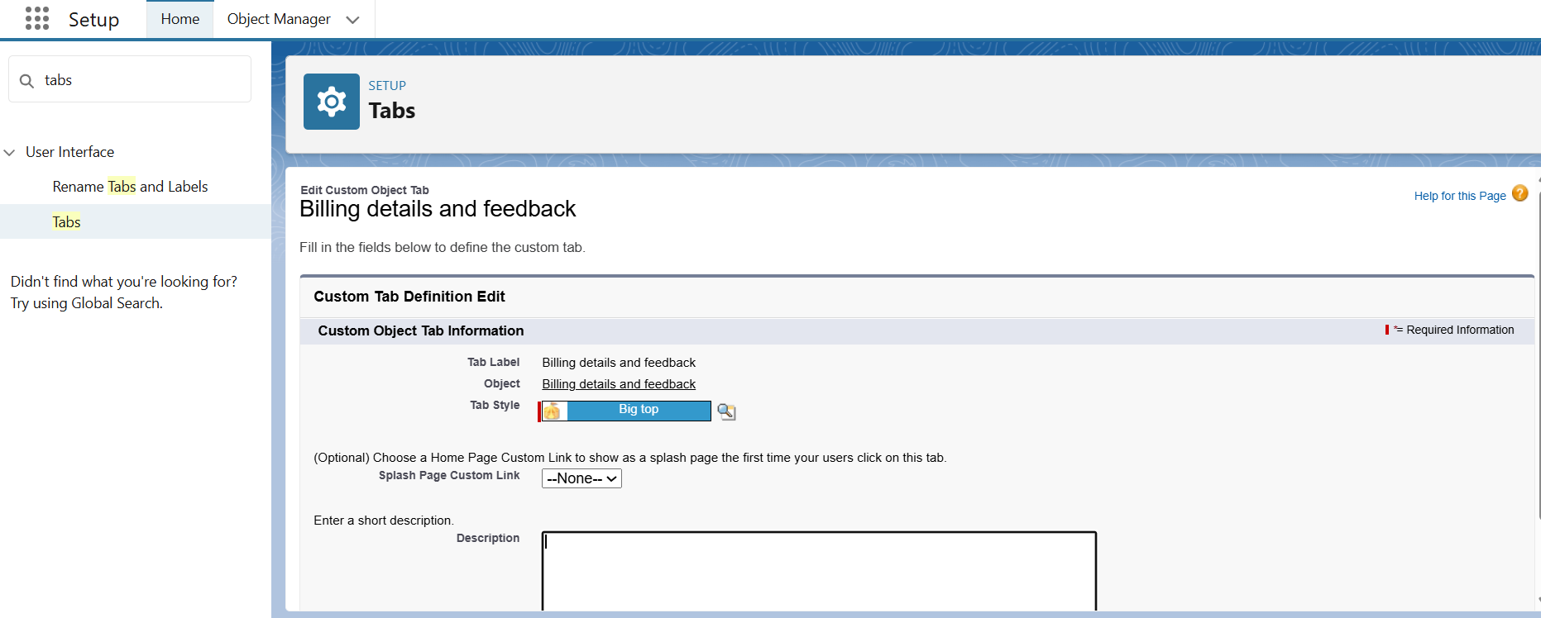

## 3. Customer_Details Tab

* **Purpose:** Centralized management of every customer's information.
* **Functions:**

Capture and update personal details: name, contact number, email,

vehicle information.

Maintain a full service history for each customer.

Rapidly search and retrieve customer records for appointments, billing, or feedback.

Supports segmentation for personalized communications and targeted offers.

* **Benefits:**

Enables quick identification and personalized service delivery.

Improves relationship management through holistic customer views.

Reduces duplication and data entry errors by consolidating all related information.

Enhances tracking for follow-up, loyalty, and re-engagement activities.

## Screenshot 2025-07-19 2127024. Service_Records Tab

* **Purpose:** Document and monitor the progress and completion of all vehicle services.
* **Functions:**

Record details of every service performed, including type, cost, mechanic,

parts used, and status.

Link each service record to related appointments and customers for full traceability.

Enable reporting on service frequency, types, outcomes, and mechanic performance.

Support for field tracking and automated updates as services progress through stages.

* **Benefits:**

Ensures comprehensive service histories for all vehicles.

Supports analysis of service trends, costs, and repeat issues.

Provides accountability by tying work performed directly to staff and

customer records.

The **\*Lightning Experience App Manager**\* in Salesforce allows you to:

- View and manage all apps in your organization.

- See details like app name, developer, description, last modified date, and app type (Lightning or Classic).

- Create a new Lightning app with the "New Lightning App" button.

- Manage and configure existing apps, such as the "Garage Management Application".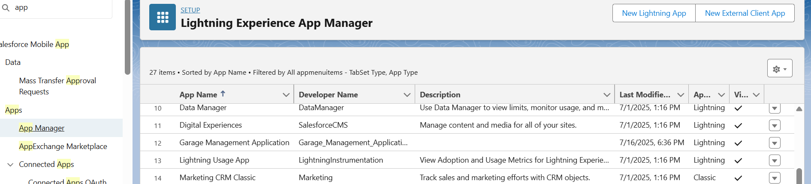

# Customer Details Object – Detailed Configuration

* The **Customer Details** object is the backbone of customer management in the Garage Management System CRM. This Salesforce custom object is structured to capture all relevant information about each customer, enabling robust service history tracking, effective communication, and reliable reporting.
* **Object Name:** Customer_Details__c
* **Purpose:** To store and manage comprehensive information about every customer interacting with the garage, including contact information, related vehicles, appointment history, and feedback records.
* The page displays the configuration of the *Customer Details* object in Salesforce.
* - The table lists the fields under "Fields & Relationships":
* - *Created By*: tracks who created the record (Lookup(User)).
* - *Customer Name*: stores the customer's name (Text(80)).
* - *Email*: stores the customer's email address (Email data type).
* - *Last Modified By*: tracks who last updated the record (Lookup(User)).
* - *Owner*: identifies the record owner (Lookup(User/Group)).
* - *Phone number*: stores the customer's phone number (Phone).

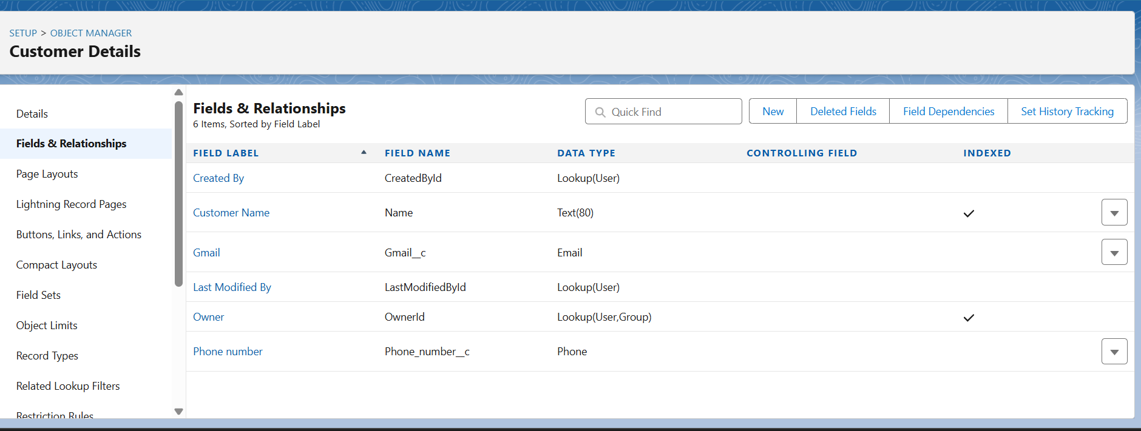

**Salesforce Lightning App Manager & Customer Details Object – Summary**

* **App Manager:**

Lists all apps (name, developer, type: Lightning or Classic).

Lets you create or edit apps for customization.

* **Customer Details Object:**

Main fields: Customer Name (Text), Email (Email), Phone Number (Phone),

Created By, Last Modified By, Owner (all Lookup).

Indexed fields (Customer Name, Owner) for faster search/filtering.

Fields can be added, removed, or changed by admins as needed.

* **Value:**

Makes it easy to organize apps and manage customer data for business needs.

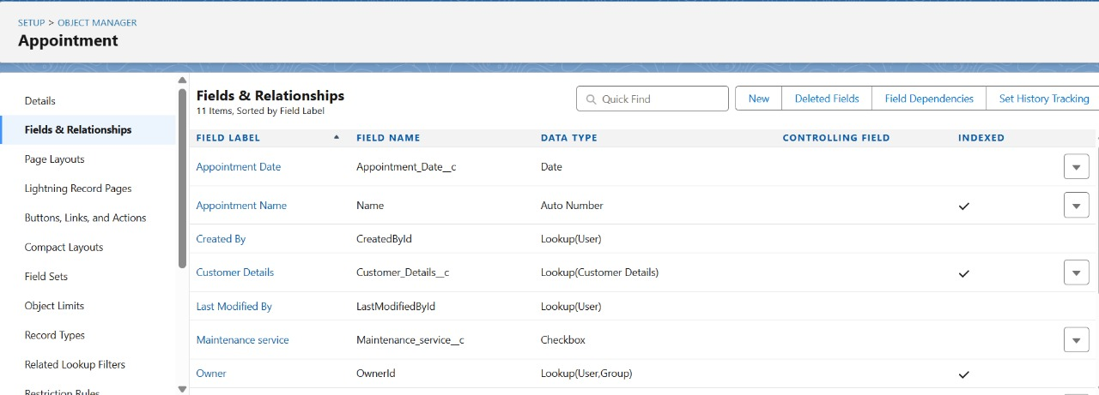

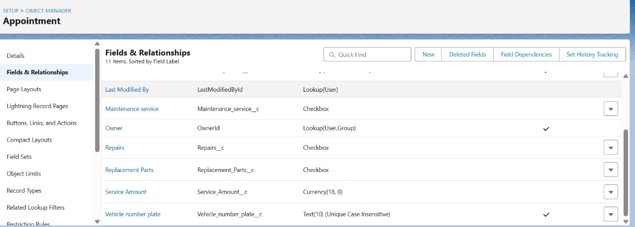

The object is titled \***Billing details and feedback**\* and lists its fields and relationships.

* Key fields include: Billing details and feedback Name (Auto Number),

Created By, Last Modified By, and Owner.

* Additional fields are Payment field (Currency),

Payment Status (Picklist), and

Rating for service (Text).

* Data types featured are Auto Number, Lookup, Currency, Picklist, and Text.
* The *Name* field is indexed for faster searches.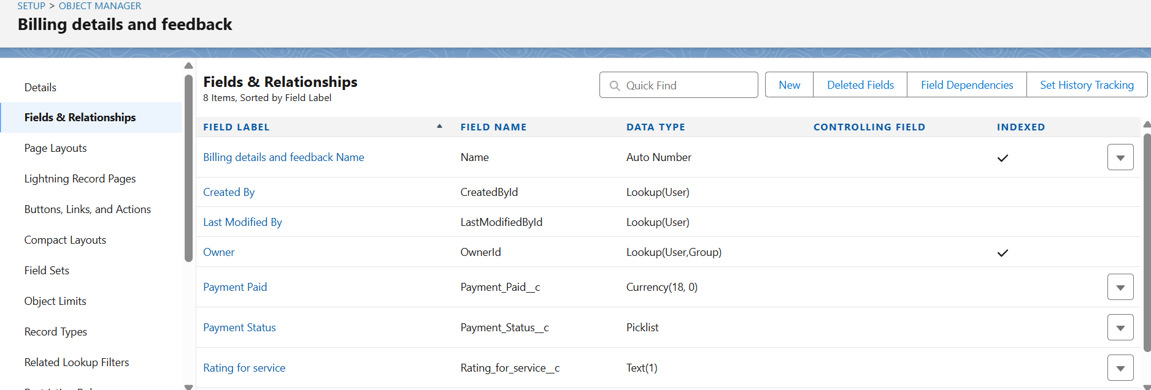

The image shows the \***Custom Field Definition Edit**\* page for the "Replacement Parts" field in the *Appointment* object in Salesforce.

* - The field label is *Replacement Parts, and its field name is **Replacement_Parts*.
* - There is an optional *Description* and *Help Text* section for additional guidance.
* - *Data Owner* is set to "User" and various record-level options are available.
* - The field can be made unique or required, and data sensitivity levels can be configured.
* - Administrators can edit, save, or cancel changes to the custom field from this page.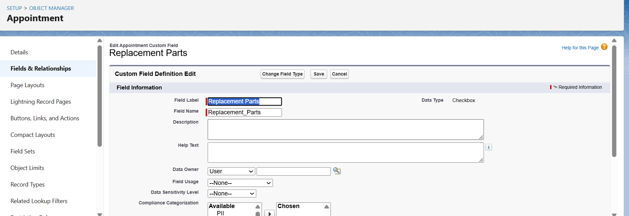
* The \***Appointment Date**\* field includes a calendar picker, making it easy to select the required date.
* When a date is chosen, it is saved in the format DD/MM/YYYY, as shown in the form.
* This ensures that the appointment is scheduled accurately for the customer.
* The interface includes related fields such as Customer Details, service type, and repair options.
* Once all fields, including the appointment date, are filled, the appointment can be saved 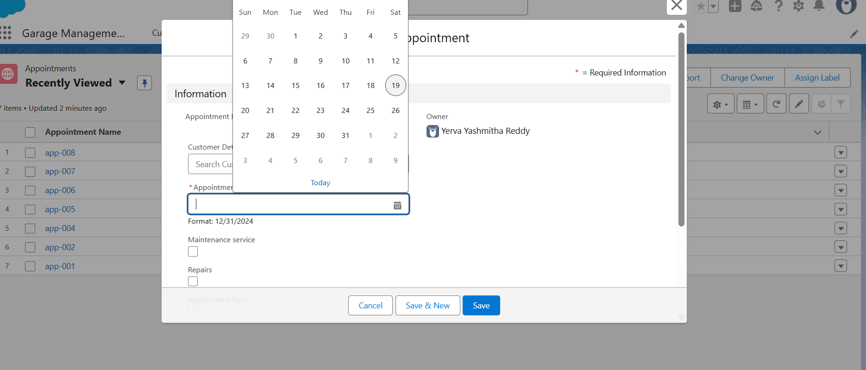
* - Users can input the **Service Amount** and the Vehicle number plate for each appointment.
* - The form provides options to Save, Save & New, or Cancel the entry at the bottom.
* - The organized structure of this interface supports efficient management and scheduling of customer appointment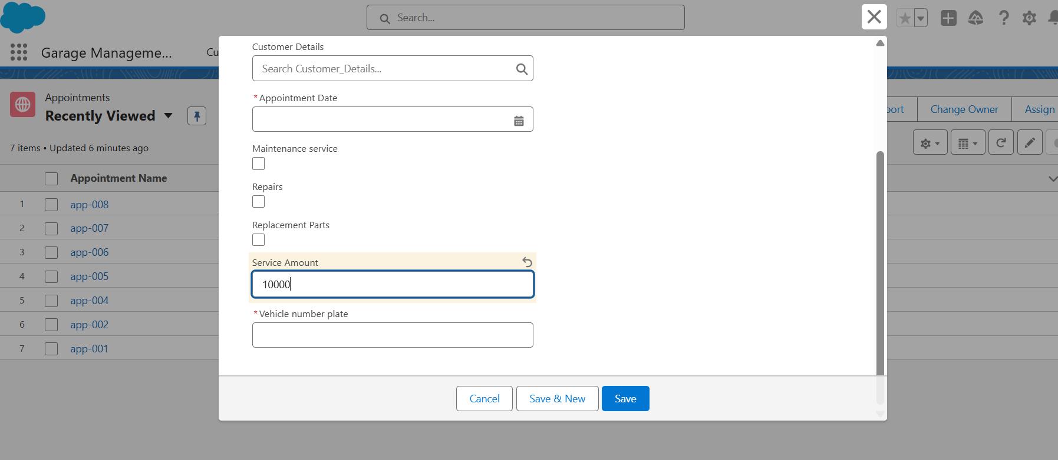
* Key form fields include Customer Details, Appointment Date, Maintenance Service, Repairs, Replacement Parts, Service Amount, and Vehicle Number Plate.
* The **Vehicle Number Plate** field provides a dropdown with suggested options, ensuring correct entry.
* Required fields are marked, with validation prompting users to complete missing information.
* Recently viewed appointment records appear in a sidebar for quick reference and navigation.
* Action buttons at the bottom allow saving the appointment, saving and opening a new one, or canceling.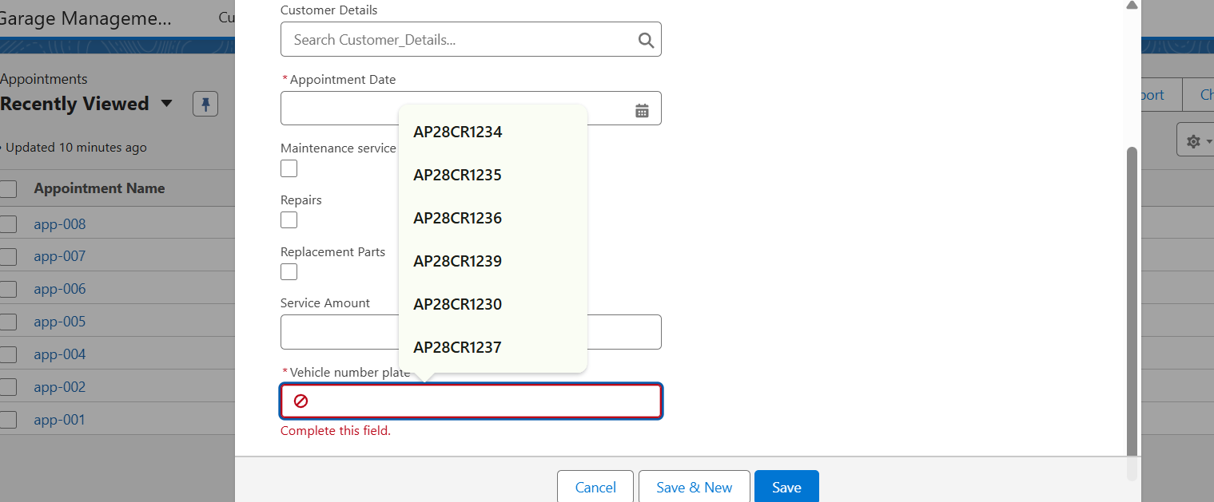
* Key fields include Service Records Name, Owner, Appointment, Quality Check Status, and Service Status.
* The **Service Status** field provides options such as None, Started, and Completed, allowing users to select the current stage of service.
* The Owner field is auto-filled with the user's name for tracking responsibility.
* Once the relevant information is entered, there are options to Save or Save & New at the bottom.
* The left sidebar lists other recently viewed service records for quick access and reference.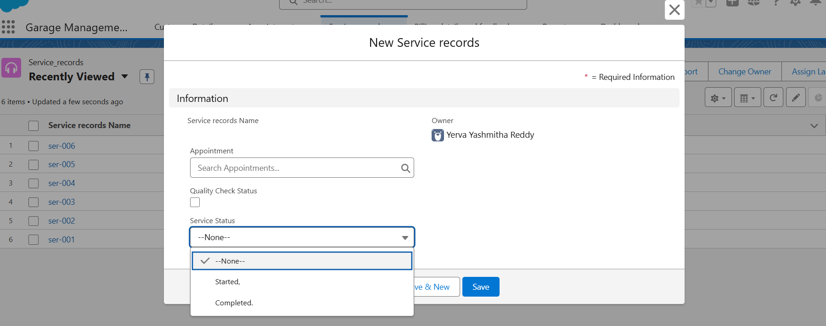 The image shows the details of a \***Service Record**\* in a garage management system.
* Key fields presented include Service Record Name, Appointment ID, Service Date, Quality Check Status, and Service Status.
* The Service Status is marked as "Completed," and the record is associated with a specific owner.
* Both creation and last modification details list the same user with timestamps.
* The interface is organized under tabs like Related and Details for easy navigation.
* This structured layout allows for efficient tracking, updating, and reference of service records.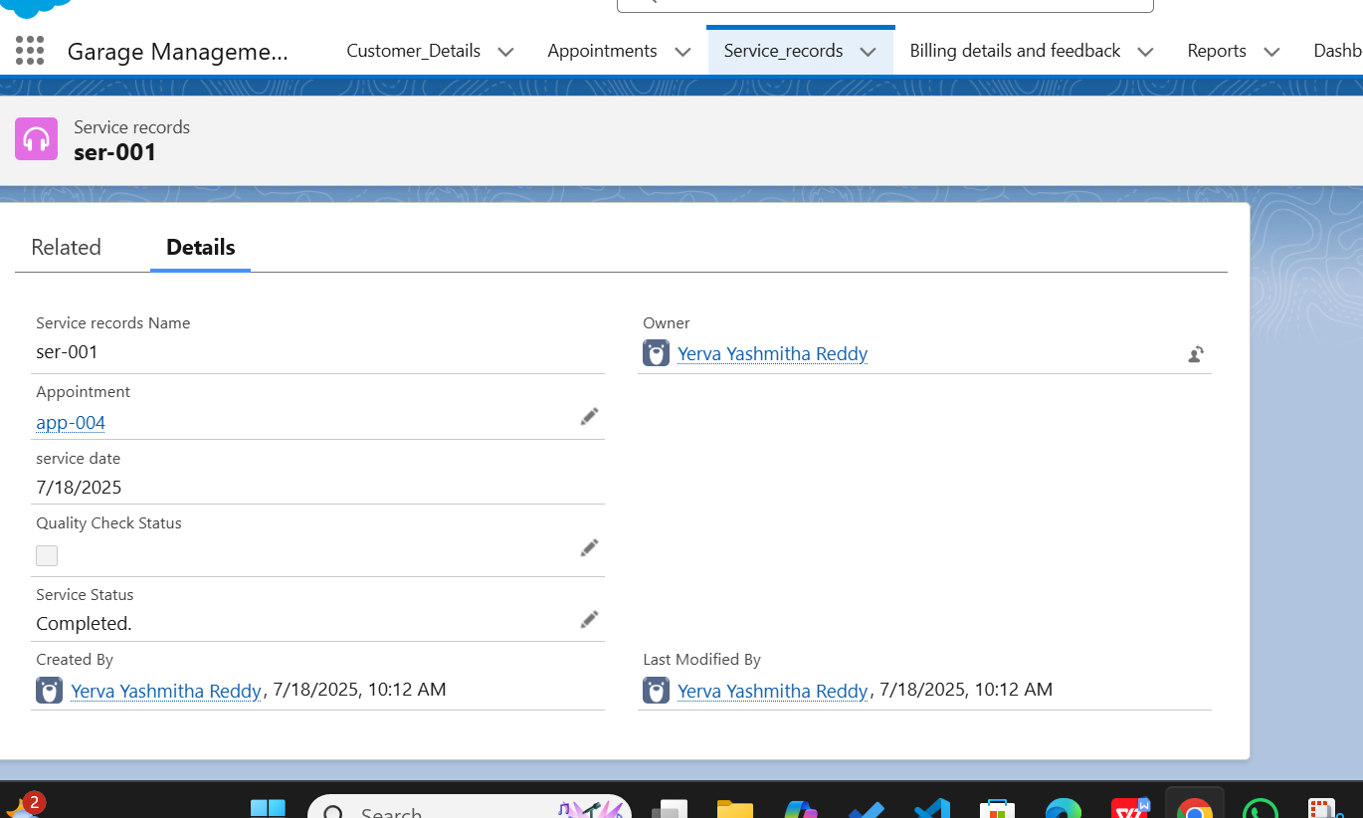\***Sample Validation Rules for Form Fields:\***

1. The *Vehicle number plate* field must not be empty or null.

2. Only alphanumeric characters are allowed in the vehicle number plate.

3. The vehicle number plate must follow the format standard for the region (e.g., two letters for state, two digits for district, one or two letters serial, four digits: “XX00XX0000”).

4. Do not allow special characters (e.g., spaces, hyphens, symbols) in the number plate field unless the official format permits.

5. The length of the vehicle number plate must be between 8 and 10 characters, matching the regional standard.

6. The vehicle number plate must not contain lowercase letters if the format requires all uppercase letters.

7. The vehicle number plate should not accept values with leading or trailing spaces.

8. Duplicate vehicle number plates are not allowed in the system.

9. The number plate entered should match existing vehicle registration validations (regex pattern rule).

10. If the vehicle number plate field is invalid, display an error message and prevent saving the record.

11. The *Service Amount* must be a numeric value greater than zero.

12. Do not allow negative values or zero in the *Service Amount* field.

13. The *Service Amount* field must not accept non-numeric or special symbols (other than decimal).

14. If “Repairs” is selected, details of repair need to be provided in a comments/description field.

15. At least one of either “Repairs” or “Replacement Parts” must be checked.

16. The date and time fields must not accept future dates if only past or present appointments are valid.

17. Mandatory fields must be enforced—cannot submit the form without completing all required fields.

18. Validations must trigger in real time (on field exit) or before final submission.

19. Error messages must clearly indicate which field is invalid and provide guidance.

20. If multiple validation errors exist, all must be reported simultaneously rather than one by one.

21. Tooltip or inline help should guide users on expected input formats.

22. The save action should be disabled until all validations pass.

23. Input for fields like *Created By* and *Created On* should be system-generated and not user-editable.

24. If an invalid value is detected, a red border or color highlight should appear on the respective field.

25. Use consistent validation rules across mobile and desktop interfaces for the same form.

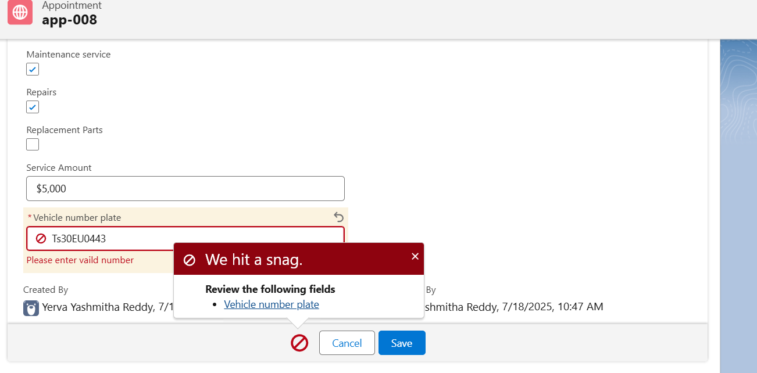The error message “We hit a snag. Rating should be from 1 to 5” indicates a *validation rule* is enforcing that the *Rating* field must have a value between 1 and 5. The system will not allow saving the record if the entered rating is outside this range or left empty when required. To resolve the issue, ensure the *Rating* field is filled with an integer from 1 to 5. This rule helps maintain *data accuracy* and consistent feedback scoring in the system.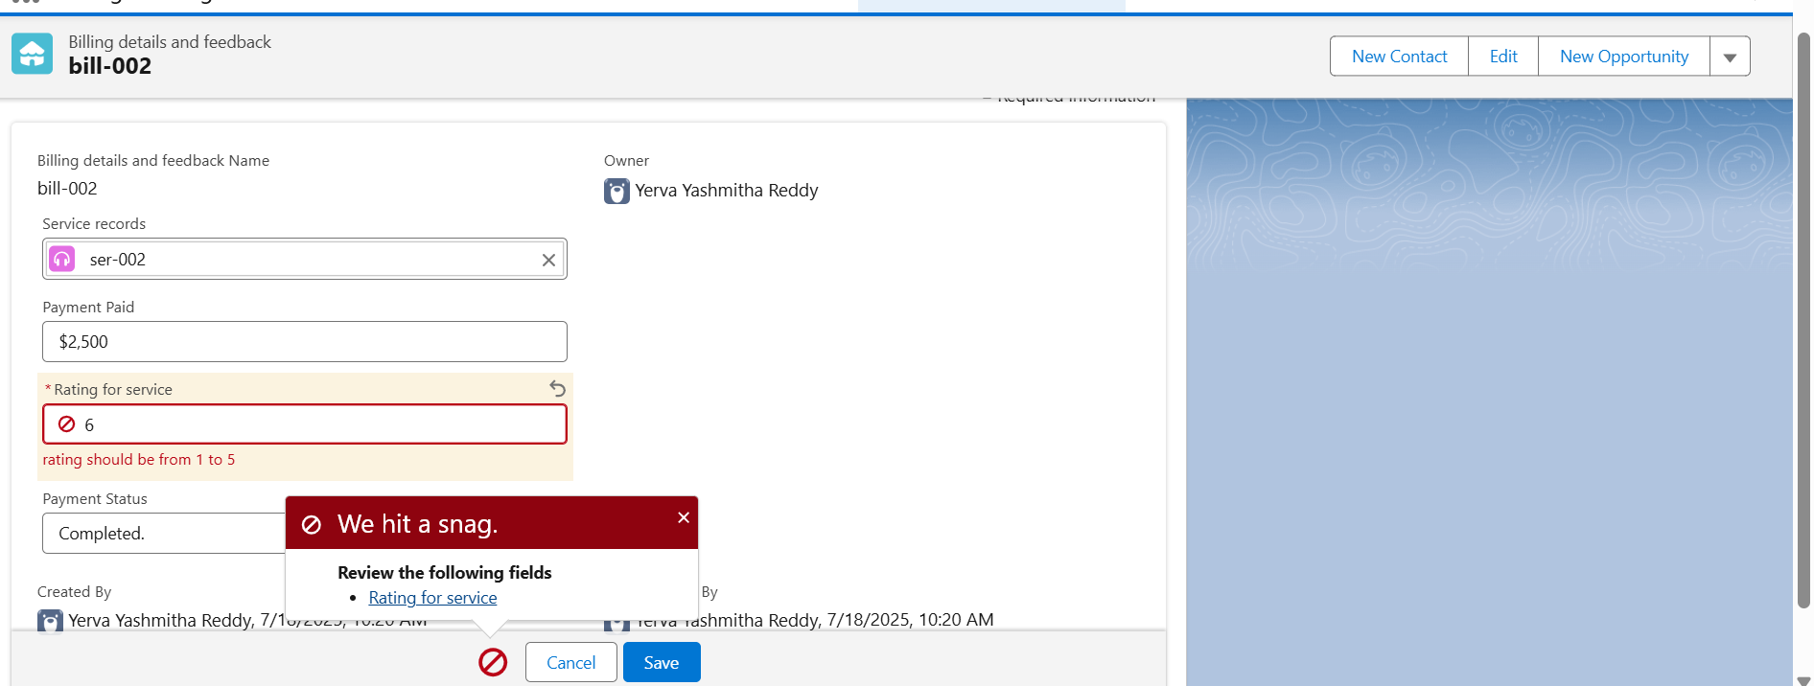1. The \***Phone number**\* field must be unique; duplicate phone numbers are not allowed.

2. The \***Gmail/Email**\* field must be unique across all customer records.

3. If a record with the same phone number or email already exists, the system should prevent saving the new record and display an error message.

4. The uniqueness check should be case-insensitive for email addresses.

5. Duplicate checks should occur in real time or at form submission.

6. Only one combination of *Phone number* and *Email* should exist in the database per customer.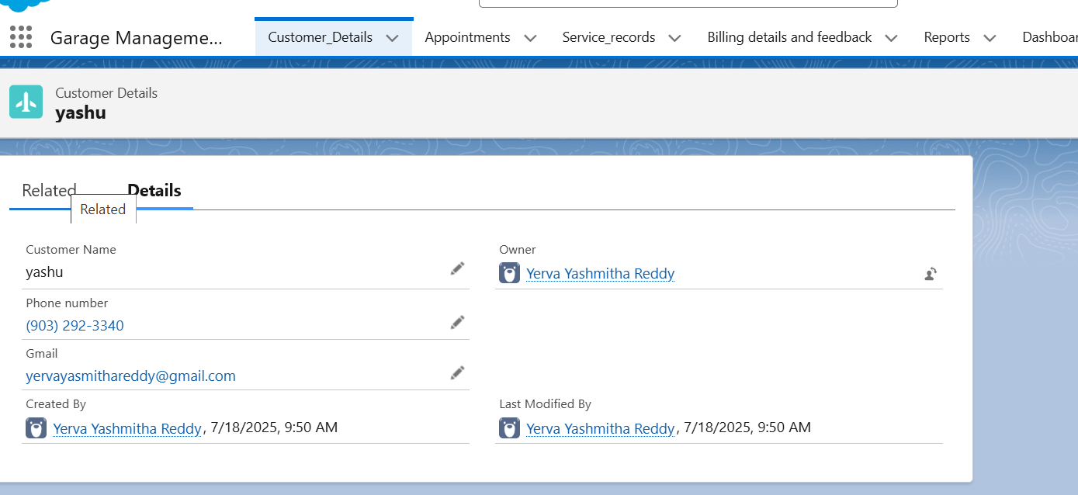

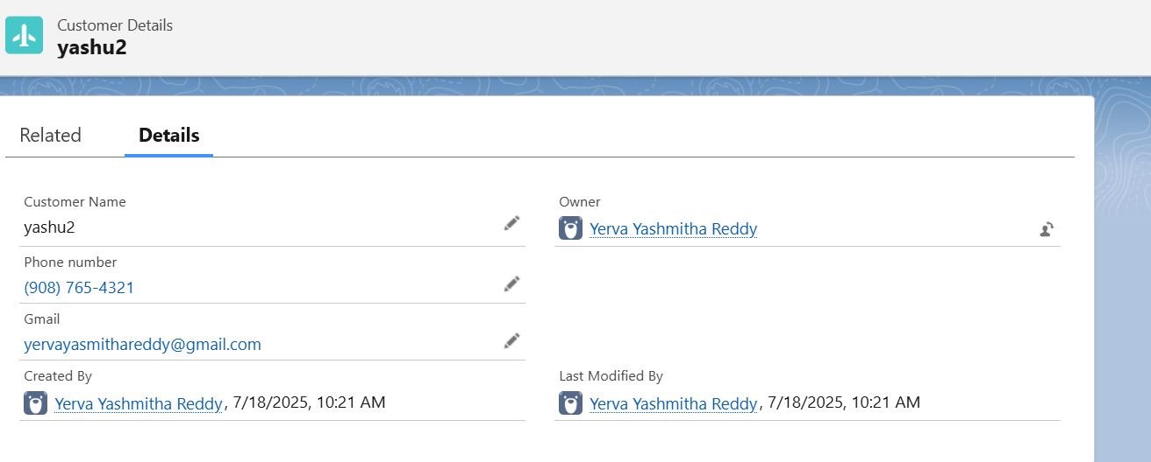

In the user management list shown, there are two records for “Mahuru, Nishuu” with the same email address and username, which is a clear duplicate. Duplicate user records can cause login issues and data inconsistencies. To prevent this, enforce unique constraints on fields like *Username* and *Email*. When a duplicate is detected, the system should display an error and not allow saving. Regular audits or automated tools can help identify and remove duplicate users for better system integrity.

* 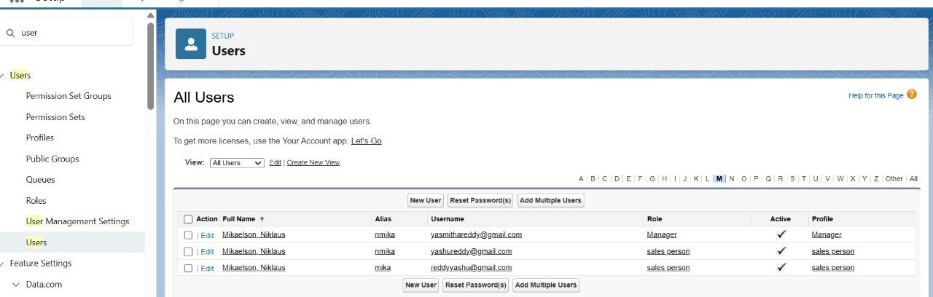The **Customer Details** object is a custom object created to store and manage information about customers who book appointments or avail services at the garage. It includes essential fields such as customer name, email, phone number, vehicle details, and address. This object serves as the foundational entity that links to appointments and service records. By associating customers with their service history and billing feedback, it helps in maintaining a centralized and organized record system. Permissions for this object were configured based on user profiles like Manager and Sales Person, ensuring that access is role-specific and secure.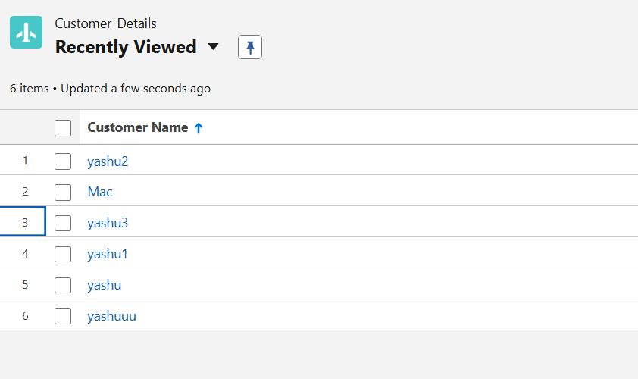
* *CEO*: Top executive overseeing organizational operations.
* *CFO*: Chief Financial Officer responsible for financial strategy and operations.
* *COO*: Chief Operating Officer managing daily business functions.
* *Manager*: Oversees teams and business processes.
* *SVP, Customer Service & Support*: Senior leader for customer service operations.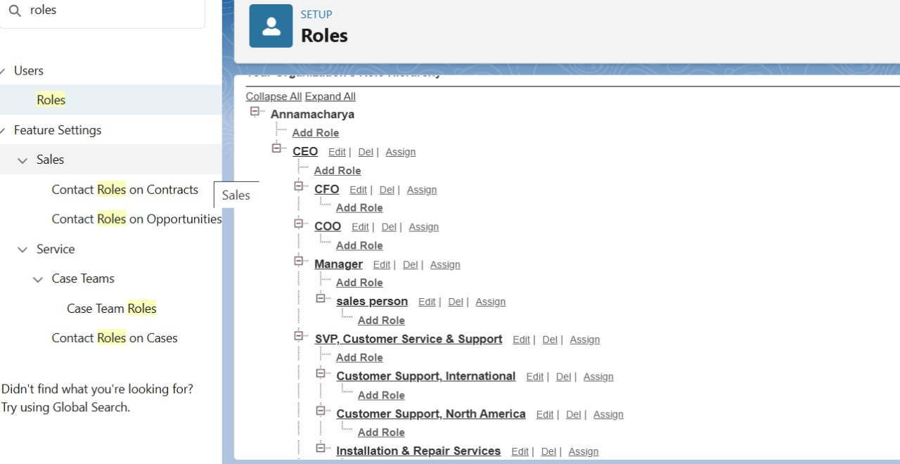The screenshot shows a **user management page** listing several roles assigned to users in the system.
* *Manager*: Supervises team activities and approvals.
* *Sales manager*: Handles sales operations and oversees the sales team.
* *System administrator*: Manages system configurations and user permissions.
* *Analytics Cloud Security User*: Accesses and secures analytics data.
* *Chatter Free User*: Collaborates and communicates using the Chatter platform.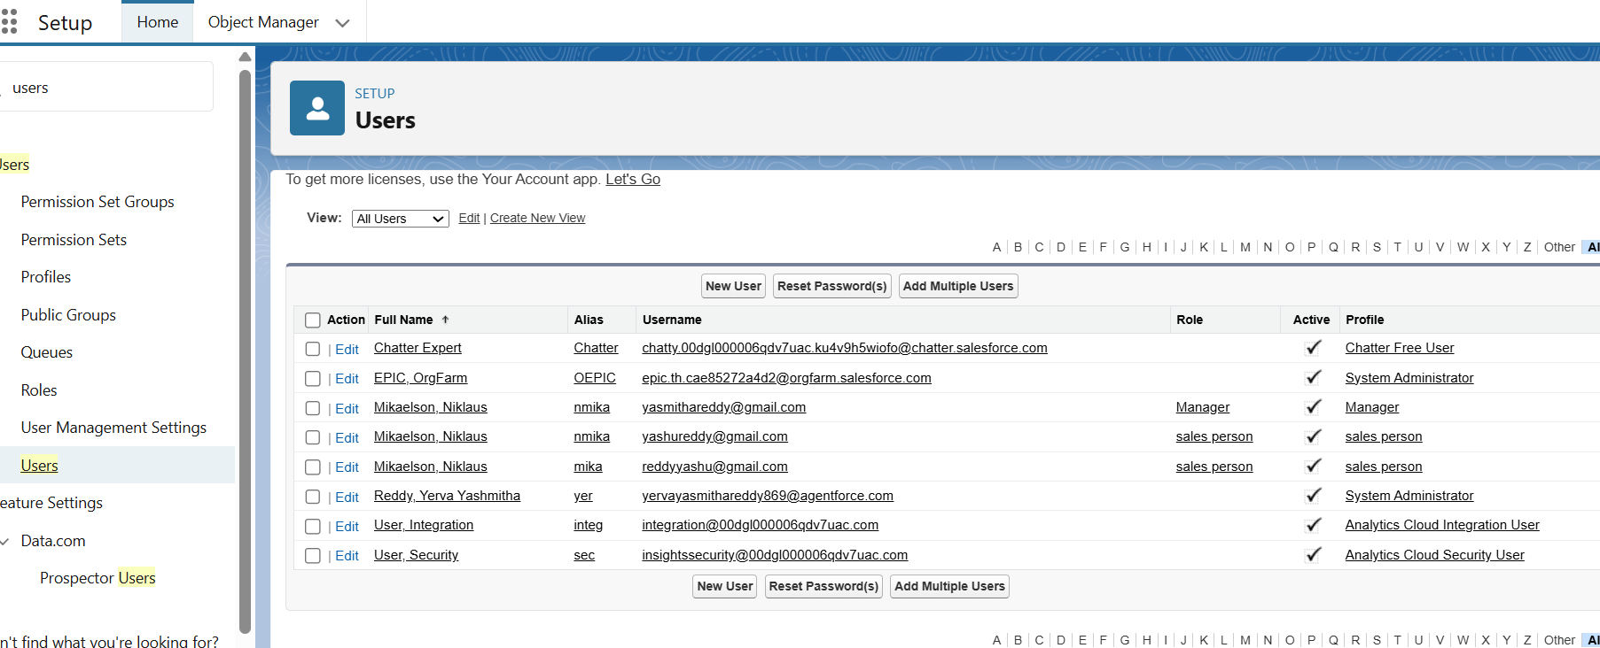

The *main function of the "**sales_team" public grou**p* in Salesforce is to simplify the management of data sharing and user permissions related to sales activities. By grouping relevant users together, administrators can efficiently control access, ensuring that sales representatives or managers collectively receive the right visibility and collaboration privileges for opportunities, leads, and related records.

* *Efficient Permission Management:* The group allows admins to grant, restrict, or manage access to Salesforce records (like leads, accounts, opportunities) for all group members at once, reducing manual effort and errors.
* *Collaboration:* Members of the sales team group can more easily share information, reports, and dashboards, helping them work together toward shared goals.
* *Security:* Access is granted only to users who are part of the group, helping to uphold data privacy and security standards.
* *Scalability:* As the team changes or grows, users can be quickly added or removed from the group without individually updating permissions on every record.

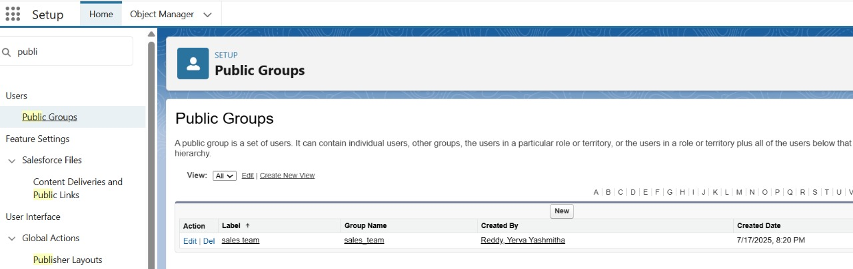The **Sharing Settings page** in Salesforce allows administrators to set the default record access level for different objects. In the image, most objects like Work Order, Work Order Line Item, and Service Reports are set to *Private, meaning only record owners and users above them in the role hierarchy can view and edit these records. However, objects like Appointment, Billing details and feedback, and Customer Details have **Public Read/Write* access, allowing all users to view and modify these records. These settings help balance data security with collaboration needs within the organization.

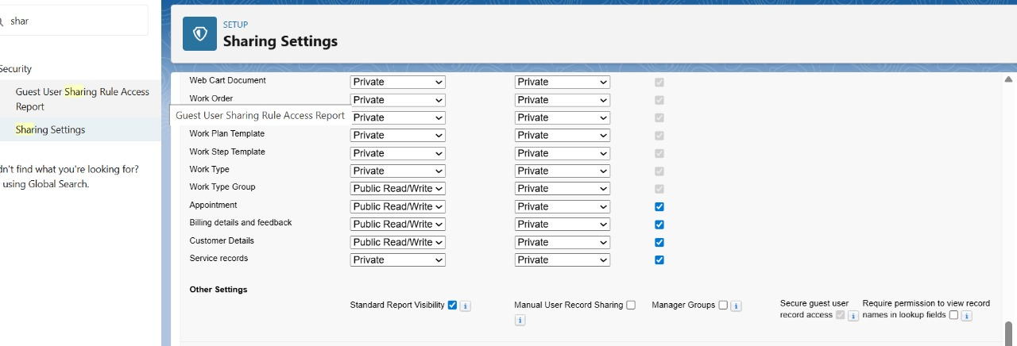 \***Multiple flows\*** are defined, each automating specific business processes such as registration, approvals, billing, and scheduling.

* The flows cover diverse process types, including *Autolaunched Flows, **Screen Flows, **Salesforce Scheduler Flows, and **Choreo/Channel Flows*.
* Flows like "Authentication Provider User Registration" and "Book Appointment from Invitation" streamline user onboarding and appointment scheduling.
* The listing shows important details for each flow: *Flow Label, **Process Type, **Package State, **Activation Status, and **Last Modified Date/User*.
* Administrators can quickly manage flows (activate, deactivate, edit) from this central page, supporting efficient process automation in Salesforce.
* · **Purpose**:  
  To implement a **loyalty reward system** that automatically assigns points to customers based on the **Billing Amount**.
* · **Trigger**:  
  The flow is triggered **when a Billing details and feedback record is created or updated**.
* · **Logic Used**:
* If Billing_Amount__c ≥ 1000 → **10 points** are added.
* If Billing_Amount__c < 1000 → **5 points** are added.
* · **Flow Type**:  
  Record-Triggered Flow optimized for **Actions and Related Records**.
* · **Elements Used**:
* **Decision Element** to check billing amount.
* **Assignment Element** to calculate points.
* **Update Records** element to update the related customer's Points__c.
* · **Outcome**:
* Encourages repeat visits and improves **customer engagement**.

Automates point tracking without manual data entry.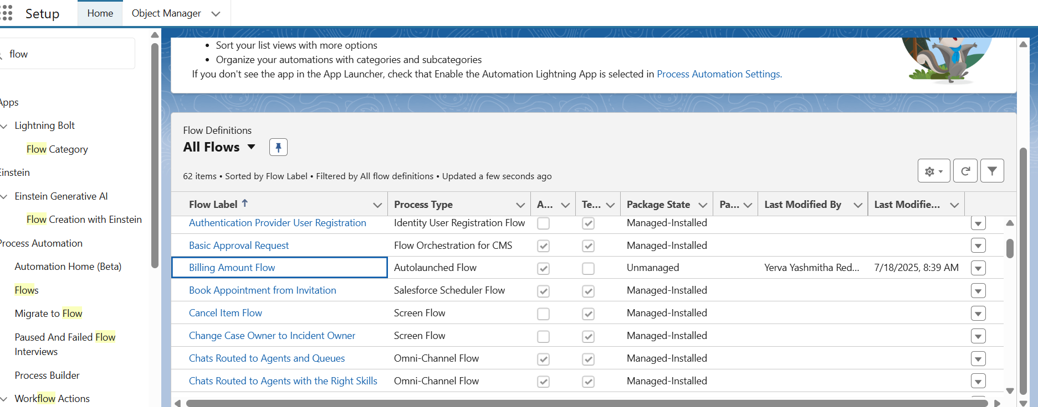This flow is a \***record-triggered automation**\* on the object *Billing details and feedback, designed to run whenever a record is created or updated. It immediately executes an **Amount Update* step that updates related records, ensuring billing information stays accurate and current. Following this, the flow sends an *Email Alert*, which likely notifies relevant users or teams about the update or important changes. Certainly! Here’s a much shorter version of your flow description:

**Record-Triggered Flow: Billing Details and Feedback**

* This flow runs automatically when a billing or feedback record is created or updated.
* It first updates the related billing amount to keep records accurate.
* Then, it sends an email alert to notify the relevant users about the change.
* This automation reduces manual work and helps keep everyone updated.

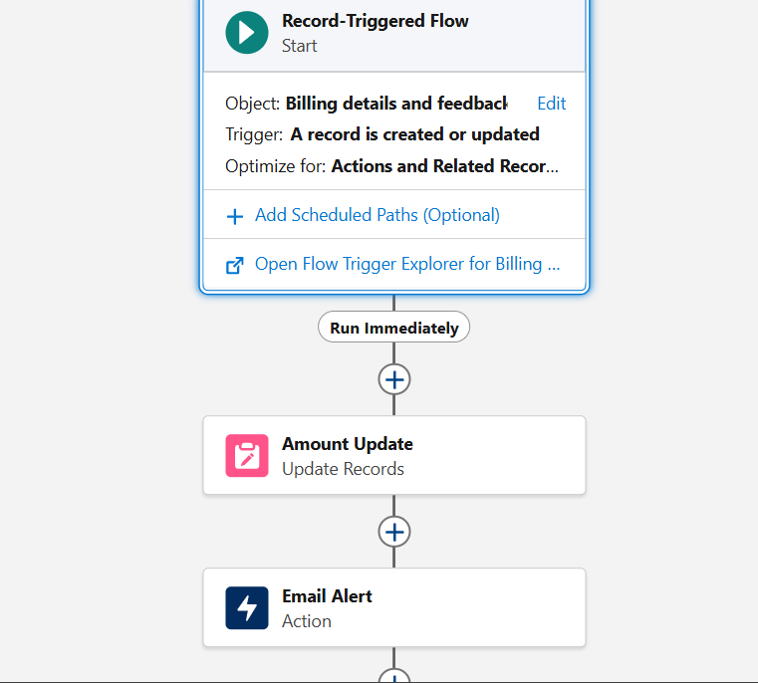

1. The interface is part of a \***Garage Management System**\* focused on managing service records.

2. The record is labeled *ser-002* and assigned to owner *Yerva Yashmithra Reddy*.

3. The service is linked to an *appointment* with the ID *app-005*.

4. The *service date* is set to *7/18/2025*.

5. There is a *Quality Check Status* field, which is a checkbox and noted as calculated upon save.

6. The *Service Status* dropdown is set to *Completed*.

7. Audit fields show both *Created By* and *Last Modified By* as *Yerva Yashmithra Reddy* on the same date and time.

8. The layout includes *Save* and *Cancel* buttons to submit or discard changes.

9. Navigation tabs at the top allow access to Customer Details, Appointments, Service Records, Billing details and feedback, and Reports.

10. The page layout is clean and user-friendly, supporting efficient data entry and record tracking.

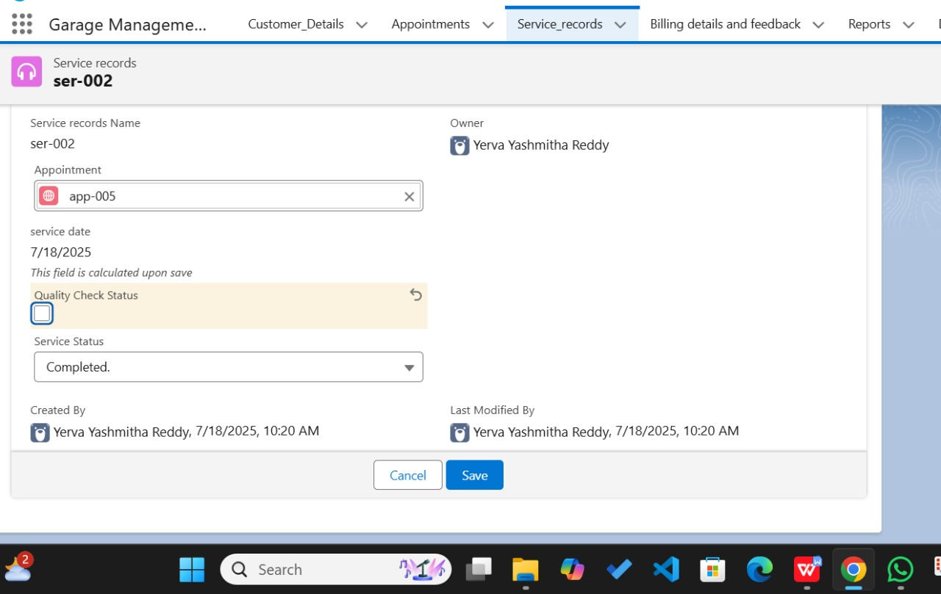

Output from program

Appointment ID:* app-005

- *Customer:* Chalse

- *Vehicle number plate:* AP04BU6284

- *Appointment date:* 2025-07-19T00:00:00.000Z

- *Maintenance service ID:* a2325678

- *Replacement parts ID:* a2367079

- *Service details:* Repairs, Replacement Parts

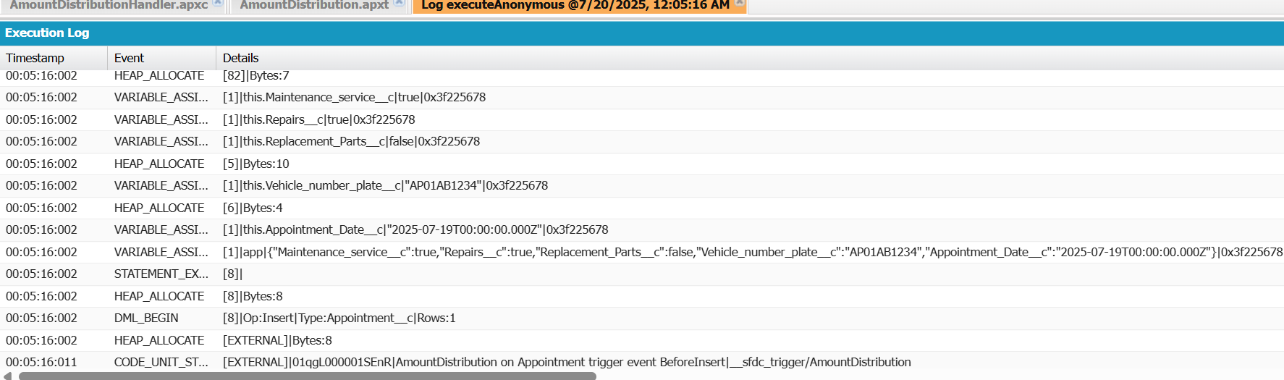

* *Report Name:* New Service Information Report
* *Folder:* Garage Management Folder
* *Created By:* Yerva Yashmithra Reddy
* *Created On:* 7/18/2025, 10:27 AM

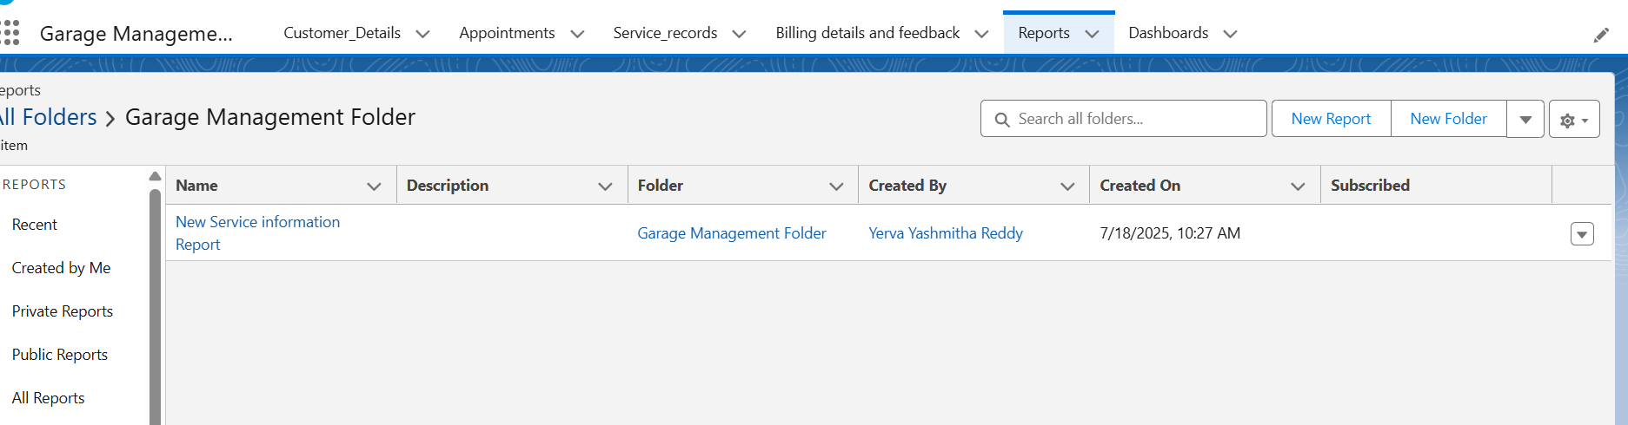

- This data comes from **the Reports section of the Garage Management System**.

* Only one report currently appears in the folder.
* Options for creating new reports or folders are available in the interface.*Report Name:* New Service Information Report
* *Customer Names:* rton#1, rton#2, rton#3
* *Service Status:* Completed (for all listed)
* *Payment Status:* $10,000 (each)
* *Appointment Numbers:* app-006, app-007, app-008
* *Total Payment (Sum):* $30,000
* *Total Records:* 3
* *Appointment Dates:* All appointments are dated 7/18/2025
* *Calculated Field:* Total payment displayed as $30,000 in the report summary
* *Status of Records:* All services are marked as "Completed"

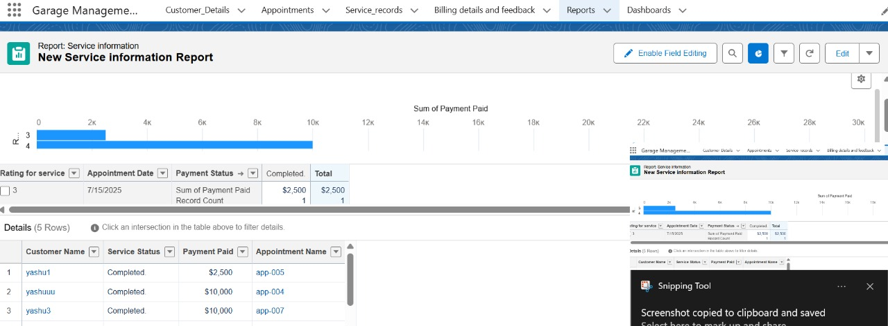 *Report Name:* New Service Information Report

- *Total Records:* 5

- *Total Payment Paid:* $42,500

**### Payment Details**

| Customer Name | Service Status | Payment Paid | Appointment Name |

|---------------|---------------|--------------|------------------|

| yeshu3 | Completed | $10,000 | app-007 |

| yeshu2 | Completed | $10,000 | app-006 |

| yeshu1 | Completed | $10,000 | app-004 |

| yeshu4 | Completed | $10,000 | app-005 |

| yeshu5 | Completed | $2,500 | app-003 |

- *Grand Total Payment Paid:* $42,500

**### Additional Context**

* The report is part of a Garage Management System.
* All listed services have a status of *Completed*.
* Billings are grouped by appointment and payment status, as shown in the sub-totals and grouped totals.

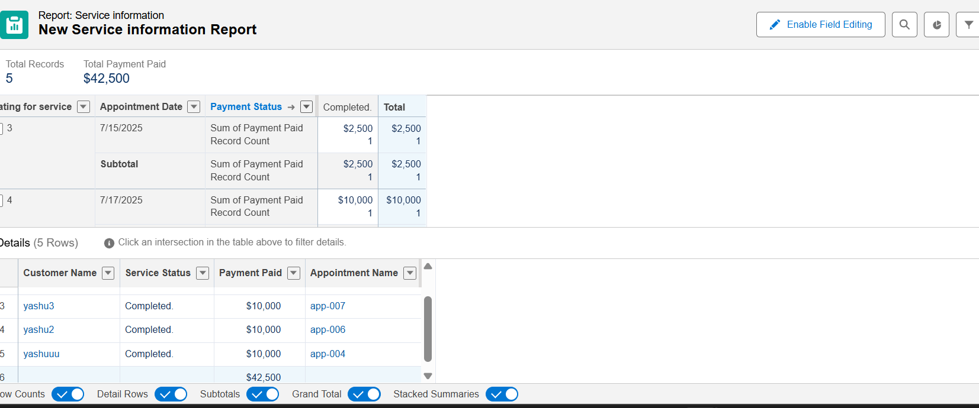 Name | Created By | Created On | Last Modified By | Last Modified Date |

|----------------------------------|------------------------|----------------------|-------------------------|------------------------|

| Enablement Dashboard (Sprint 4) | Automated Process | 7/19/2025, 1:16 PM | Automated Process | 7/19/2025, 1:16 PM |

| Enablement Dashboard Source | Automated Process | 7/19/2025, 1:15 PM | Automated Process | 7/19/2025, 1:15 PM |

| Service Rating Dashboard | Venu Vemiretta Reddy | 7/19/2025, 10:28 AM | Venu Vemiretta Reddy | 7/19/2025, 10:28 AM |

**### Folders & Navigation**

* *All Folders* is selected—showing all dashboards regardless of folder or owner.
* Sidebar lists navigation options:
* All Dashboards
* Private Dashboards
* Shared Dashboards
* Folders: All Folders

**### Dashboard Management Actions**

* Options to create new dashboards or new folders are provided via buttons in the top-right.
* Search functionality allows users to find dashboards by name or attribute.

**## Application Header Menus**

The application header provides navigation to core features:

* Customers Details
* Appointments
* Service Records
* Billing Details and Feedback
* Reports
* Dashboards

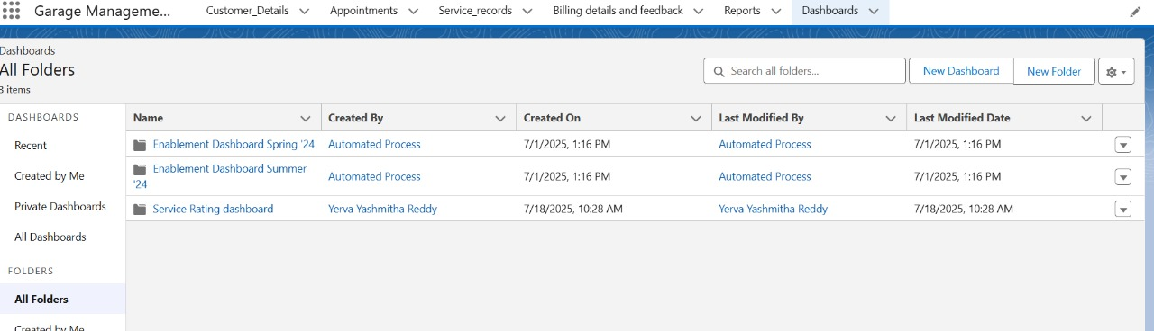

*Total Payments Collected:* $43,000

* *Payments by Appointment Date:*
* July 14, 2025: $10,000 (twice)
* July 15, 2025: $12,500
* July 17, 2025: $10,000 (twice)

The horizontal bar chart (left) shows each appointment date and how much was paid on that day—most are $10,000, except for July 15, which is $12,500. The gauge (right) and large number (left bottom) both confirm the total amount collected: *$43,000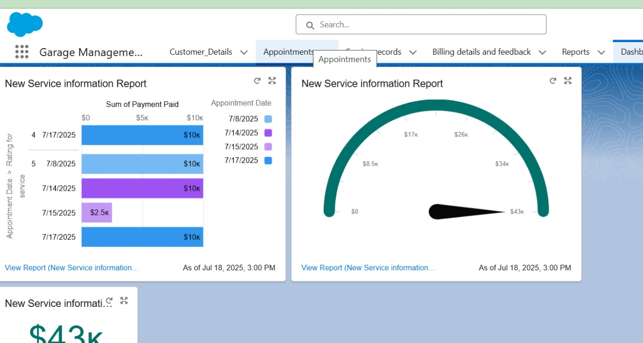

## Social Impact

* **Better Customer Experience:** Customers receive timely reminders, notifications, and transparent invoices—leading to reduced wait times and fewer service errors. This boosts trust and satisfaction.
* **Empowered Employees:** Staff can handle bookings, service assignments, and customer follow-ups more efficiently thanks to automated workflows and clear, role-based access.
* **Transition to Digital:** Moving from paper-based to digital records improves digital literacy among garage staff and reduces paperwork, supporting modern workforce skills.
* **Transparency:** Service histories, billing, and communications are all traceable, reducing disputes and building community trust in the garage’s services.

## Business Impact

* **Operational Efficiency:** Automation of tasks like appointment scheduling, service tracking, and billing minimizes manual errors and streamlines daily processes—leading to faster turnaround times.
* **Data-Driven Management:** Real-time dashboards and custom reports equip managers with actionable insights for resource planning, inventory control, and business growth strategies.
* **Customer Loyalty and Retention:** Centralized data and timely, transparent communications result in higher customer retention and recurring service visits.
* **Competitive Advantage:** A digital CRM system increases a garage's credibility, supports professional standards, and differentiates it from less organized competitors.
* **Regulatory Compliance:** Structured data management ensures readiness for audits and compliance with data protection and financial regulations.

## Conclusion

The **Garage Management System** built on Salesforce provides a powerful, centralized solution to streamline and digitize the daily operations of a vehicle service center. By integrating customer management, appointment booking, service tracking, billing, and feedback collection into one platform, the system enhances operational efficiency and customer satisfaction. The use of custom objects, automation flows, Apex triggers, dashboards, and reports ensures that all stakeholders—service staff, managers, and customers—remain well-informed and coordinated.

This CRM not only simplifies administrative tasks but also provides meaningful business insights through analytics and performance tracking. Overall, the project successfully addresses key business needs such as improved service delivery, faster communication, better data visibility, and stronger customer relationships, making it a vital tool for modern garage operations.

## Future Scope

* **Mobile App:** Make a mobile app so customers and mechanics can check bookings and updates on the go.
* **Online Payments:** Add options for customers to pay bills online, making payments faster and easier.
* **AI Chatbot:** Use a chatbot for automated customer support and booking—no need to call or wait.
* **Auto Reminders:** Send automatic SMS or email reminders for service due dates and appointments.
* **More Reports:** Create new types of reports for better analysis of services, income, and customer feedback.
* **IoT Integration:** Connect with smart devices in vehicles for automatic health checks and faster service alerts.
* **Multi-branch Management:** Allow one system to work across multiple garage locations with shared data.
* **Stronger Security:** Add new security features like 2-step login to keep customer data safe.
* **Loyalty Programs:** Offer discounts or points for regular customers to keep them coming back.
* **Easy Connections:** Integrate with other services like accounting software, spare part suppliers, or insurance.

## References

* Salesforce Help Documentation — Automation & Object Configuration
* Salesforce Trailhead: Build Custom Apps with Lightning Experience
* ScienceDirect: The Business Value of CRM Systems in Service Industries
* GeeksforGeeks: Database Relationships and Data Models
* Official Salesforce Release Notes on Lightning Experience

These references support key topics in this project report, including Salesforce setup, automation, data modeling, business benefits of CRM solutions, and user interface upgrades. For detailed Salesforce implementation guidance, the official Salesforce Help and Trailhead learning modules were utilized. Industry insights into CRM best practices and the impact of digital systems in service businesses are supported by ScienceDirect and other reliable online educational resources.